History of C Language



**History of C language** is interesting to know. Here we are going to discuss a brief history of the c language.

**C programming language** was developed in 1972 by Dennis Ritchie at bell laboratories of AT&T (American Telephone & Telegraph), located in the U.S.A.

**Dennis Ritchie** is known as the **founder of the c language**.

It was developed to overcome the problems of previous languages such as B, BCPL, etc.

Initially, C language was developed to be used in **UNIX operating system**. It inherits many features of previous languages such as B and BCPL.

Let's see the programming languages that were developed before C language.

|  |  |  |
| --- | --- | --- |
| **Language** | **Year** | **Developed By** |
| Algol | 1960 | International Group |
| BCPL | 1967 | Martin Richard |
| B | 1970 | Ken Thompson |
| Traditional C | 1972 | Dennis Ritchie |
| K & R C | 1978 | Kernighan & Dennis Ritchie |
| ANSI C | 1989 | ANSI Committee |
| ANSI/ISO C | 1990 | ISO Committee |
| C99 | 1999 | Standardization Committee |

Features of C Language

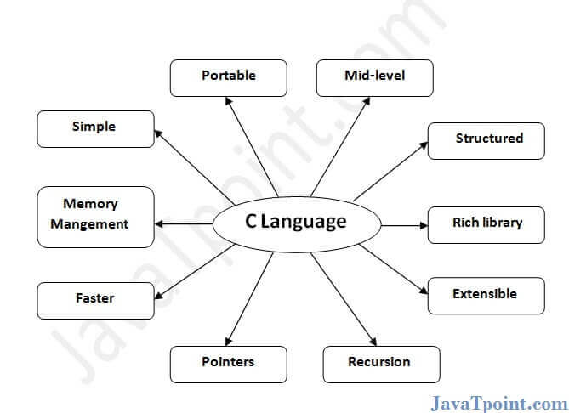

C is the widely used language. It provides many **features** that are given below.

1. Simple
2. Machine Independent or Portable
3. Mid-level programming language
4. structured programming language
5. Rich Library
6. Memory Management
7. Fast Speed
8. Pointers
9. Recursion
10. Extensible

1) Simple

C is a simple language in the sense that it provides a **structured approach** (to break the problem into parts), **the rich set of library functions**, **data types**, etc.

2) Machine Independent or Portable

Unlike assembly language, c programs **can be executed on different machines** with some machine specific changes. Therefore, C is a machine independent language.

3) Mid-level programming language

Although, C is **intended to do low-level programming**. It is used to develop system applications such as kernel, driver, etc. It **also supports the features of a high-level language**. That is why it is known as mid-level language.

C is a structured programming language in the sense that **we can break the program into parts using functions**. So, it is easy to understand and modify. Functions also provide code reusability.

5) Rich Library

C **provides a lot of inbuilt functions** that make the development fast.

6) Memory Management

It supports the feature of **dynamic memory allocation**. In C language, we can free the allocated memory at any time by calling the **free()** function.

7) Speed

The compilation and execution time of C language is fast since there are lesser inbuilt functions and hence the lesser overhead.

8) Pointer

C provides the feature of pointers. We can directly interact with the memory by using the pointers. We **can use pointers for memory, structures, functions, array**, etc.

9) Recursion

In C, we **can call the function within the function**. It provides code reusability for every function. Recursion enables us to use the approach of backtracking.

10) Extensible

C language is extensible because it **can easily adopt new features**.

# First C Program

Before starting the abcd of C language, you need to learn how to write, compile and run the first c program.

To write the first c program, open the C console and write the following code:

1. #include <stdio.h>
2. **int** main(){
3. printf("Hello C Language");
4. **return** 0;
5. }

**#include <stdio.h>** includes the **standard input output** library functions. The printf() function is defined in stdio.h .

**int main()** The **main() function is the entry point of every program** in c language.07

**printf()** The printf() function is **used to print data** on the console.

**return 0** The return 0 statement, returns execution status to the OS. The 0 value is used for successful execution and 1 for unsuccessful execution.

## **How to compile and run the c program**

There are 2 ways to compile and run the c program, by menu and by shortcut.

### **By menu**

Now **click on the compile menu then compile sub menu** to compile the c program.

Then **click on the run menu then run sub menu** to run the c program.

### **By shortcut**

**Or, press ctrl+f9** keys compile and run the program directly.

You will see the following output on user screen.

